# WEBSITE DEVLOPMENT PROJECT

## **PROJECT NAME:** I LOVE TRAVEL (A Travel Agency Website)

* **SUBMITTING TO:**

## Mr. Mayur Dev Sewak General Manager, Operations Eisystems Services

* 1. Ms. Mallika Srivastava

## Trainer, Programming & Algorithms, Eisystems Services

* **SUBMITTING BY:**

1. PAVAN KARTHIK

([Pavankarthik0610@gmail.com](mailto:Pavankarthik0610@gmail.com)), Kurnool, Andhra Pradesh

**(Group Members)**

1. B NAGA CHARAN

([nagacharan628@gmail.com](mailto:nagacharan628@gmail.com)), Kurnool, Andhra Pradesh

1. V MOHAMMAD SAMI

([samishaik134@gmail.com](mailto:samishaik134@gmail.com)), Kurnool, Andhra Pradesh

1. T DURGA SAI PRASAD

([thakkasiladurga@gmail.com](mailto:thakkasiladurga@gmail.com)), Kurnool, Andhra Pradesh

1. SAI VARDHAN

([saivardhan1917@gmail.com](mailto:saivardhan1917@gmail.com)), Kurnool, Andhra Pradesh

**Content Table**

|  |  |  |
| --- | --- | --- |
| **Serial No.** | **Title** | **Page No.** |
| **1.** | **Cover page** | **1** |
| **2.** | **Content table** | **2** |
| **3.** | **List of figures** | **2** |
| **4.** | **Abstract of project** | **3** |
| **5.** | **Project summary** | **3** |
| **6.** | **Objectives of Project** | **4** |
| **7.** | **Details of project developed** | **4** |
| **8.** | **System Requirements used** | **6** |
| **9.** | **Data/website Flow Diagram** | **6** |
| **10.** | **Input/output database screenshots** | **7** |
| **11.** | **References** | **19** |

**List of Figures**

1. Details of Project developed :
   * Caption: Details of Project developed
   * Page No : 5
   * Figure No:1
2. Data Flow Diagram:
   * Caption : Data/website Flow Diagram
   * Page No : 6
   * Figure No:2

# Abstract of Project

## **Project Title : I LOVE TRAVEL (A Travel Agency Website**)

* The goal was to create a Travel Agency website for the hypothetical clients.
* I thought of having a Travel Agency name as ‘**I LOVE TRAVEL’** for my website.
* “I LOVE TRAVEL” (A Travel Agency website) designed hypothetically help users to see through our website and explore more travelling destinations.
* Each and every menu in the ‘Menu list’ helps the hypothetical client to interact with us in each and every scenario of thought of having a ‘Travel around the world’.
* “I LOVE TRAVEL” (A Travel Agency website) make the client user-friendly through our website in exploring the travelling destinations and a easy access of booking the perfect resort for the family and their loved ones.

# Project Summary

## **Project Title : I LOVE TRAVEL (A Travel Agency Website)**

* “I LOVE TRAVEL” is a travel agency website which is used to interact with the customers to visit different travel destinations.
* There are several advantages to using “I LOVE TRAVEL” website:

1. Provides the searching facilities on various factors based on their budgets.
2. Tracks the details of customers by signing-in to our website.
3. It contains user-friendly budget hotel packages.
4. It contains all resorts/hotel information about different travel destinations.
5. I LOVE TRAVEL provides different resorts client feedback and reviews by this ,users can pick their perfect destination spots.

# Objectives Of Project

* The main objective of “I LOVE TRAVEL” (a travel agency website) is to make the clients explore different travel destinations.
* “I LOVE TRAVEL” makes the clients user-friendly in accessing of my website.
* A login page for the client is designed in my website to embrace their travel destination dreams through their details.
* A one click easy booking slots of different type of hotels which makes my website user-friendly.
* The clients queries can be easily solved with my contact page in website which makes the clients to interact with my travel agency.
* It tracks all the details about the every hotels/resorts Charges and Bookings and the latest trending packages available for the clients to book the resort/hotel

# 

# Details of project developed

* For better designing of website, **HTML** and **CSS** are used
* The website comprises of 4 major modules with their sub-modules as follows:

1. **Home**
2. Explore Hotels: This menu helps to see through the hotels in various destinations.
3. Login Page: This login page helps to sign-in in our website through your credentials.
4. **Packages**: This menu helps the clients to see the trending travel destination trending packages.
5. **Gallery**: This menu consists of different travel destinations sceneries.
6. **Contact**: This menu helps to interact with our website.

Analyzing the theme to build website

Building the code

Running and De-bugging the code

Error Rectifying

Running and De-bugging the code

Scope and Requirements

**Fig1.Details of project developed**

# System Requirement Used

1. Windows 11
2. Visual Studio
3. A good Ethernet connection
4. Images from the internet

**Data/Website Flow Diagram**

**Website type:**

**A travel agency**

I LOVE TRAVEL Website

**Menu bar**

Packages

Home

Gallery

Contact

Latest and trending Travel destination **packages**

Photo Gallery of different travel destinations

A query form for clients to contact the website

Explore Hotels

Login/sign-up form

**Fig2.Data/Website Flow Diagram.**

**Input& Output database screenshots**

1. **Cover/Home page** code of I LOVE TRAVEL website:

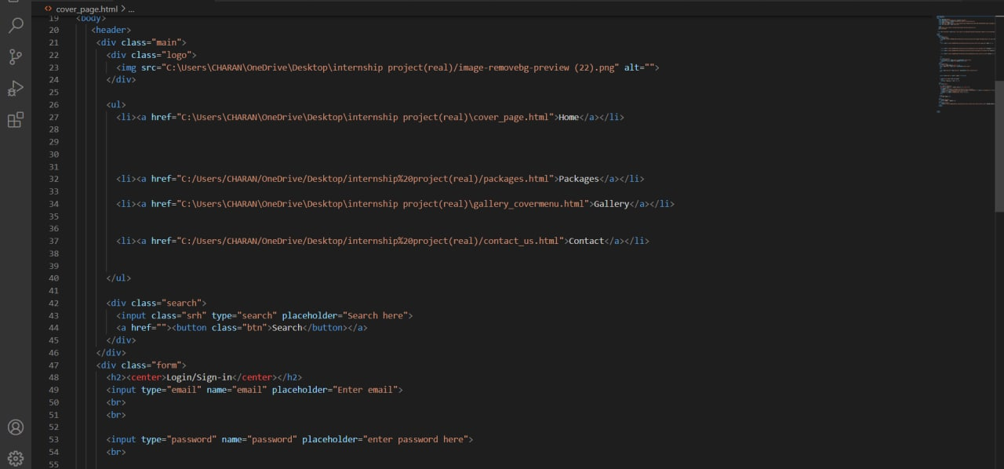

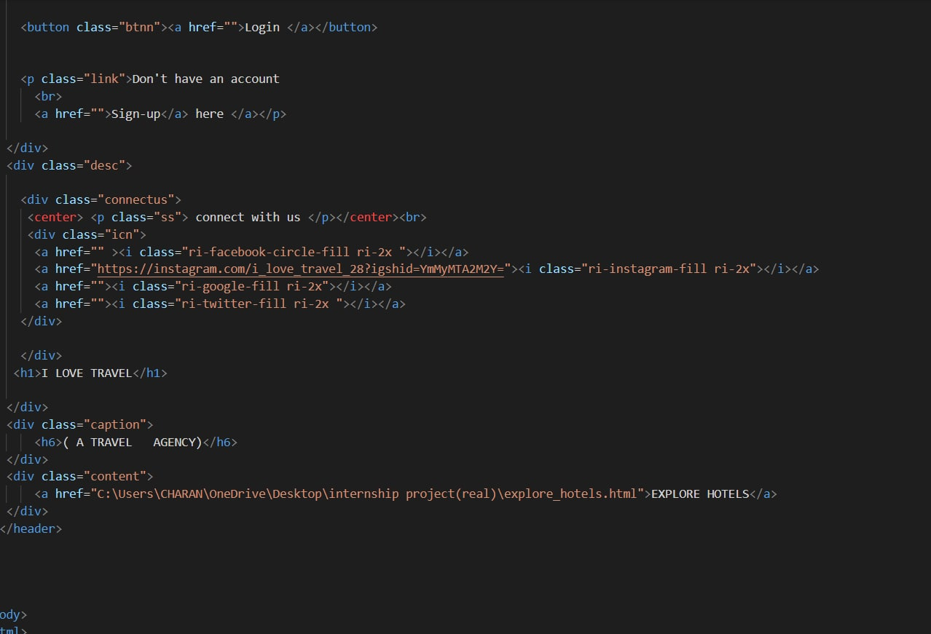

1. **Packages** code of I LOVE TRAVEL website:

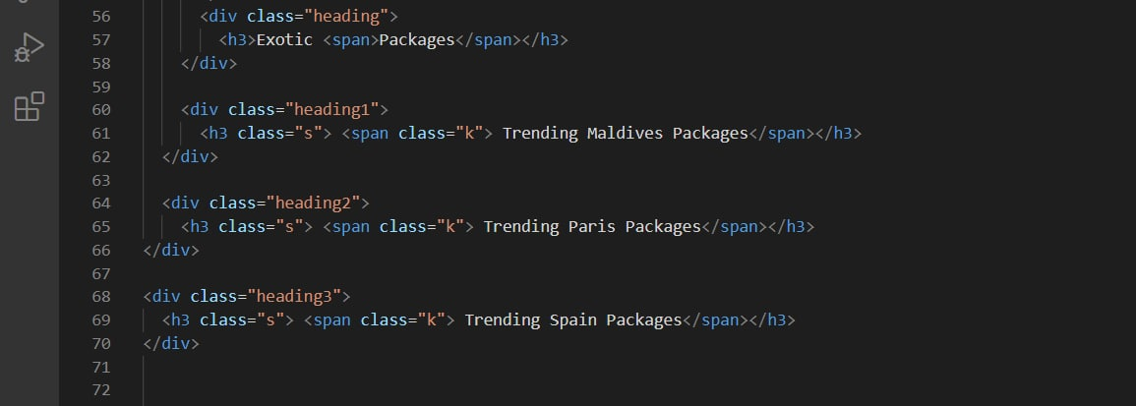

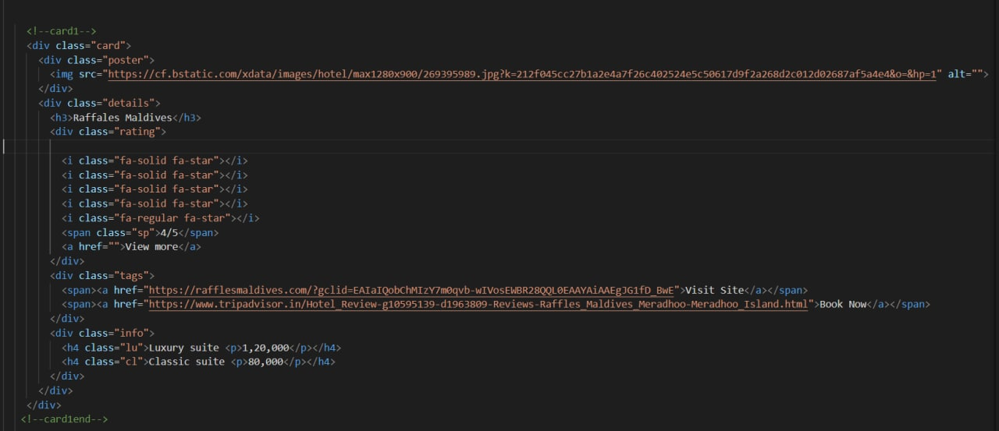

1. **Packages:** Hover effect code on packages cards information:

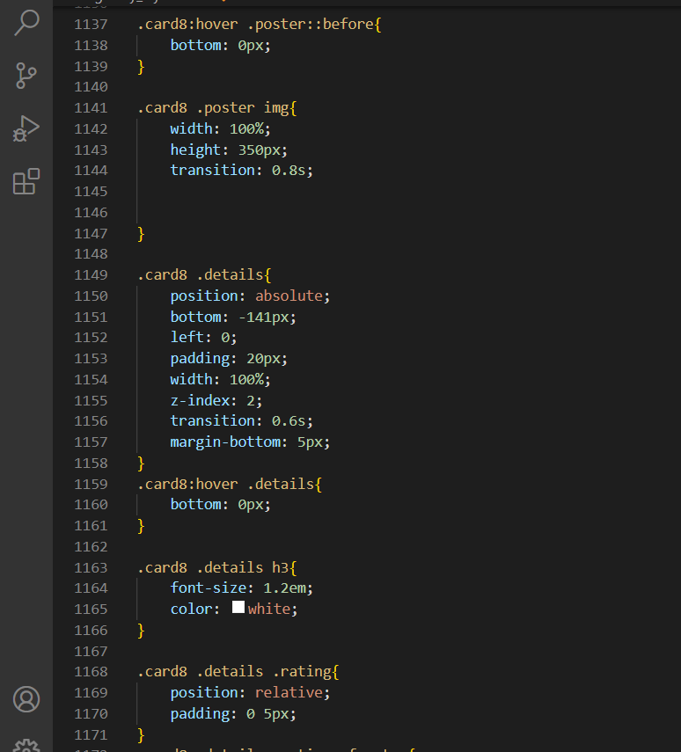

1. **Gallery:** Photo Gallery code of Travel destinations.

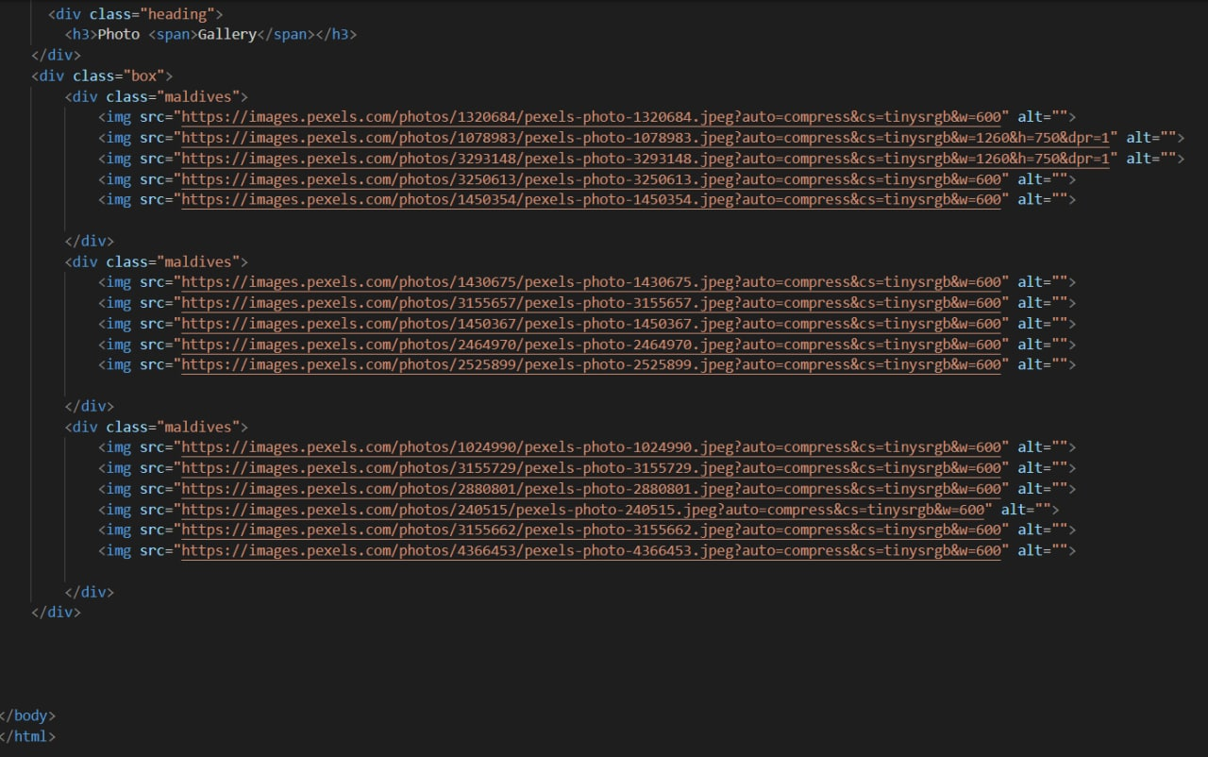

1. **Contact:** This Navigation menu bar helps to contact us.

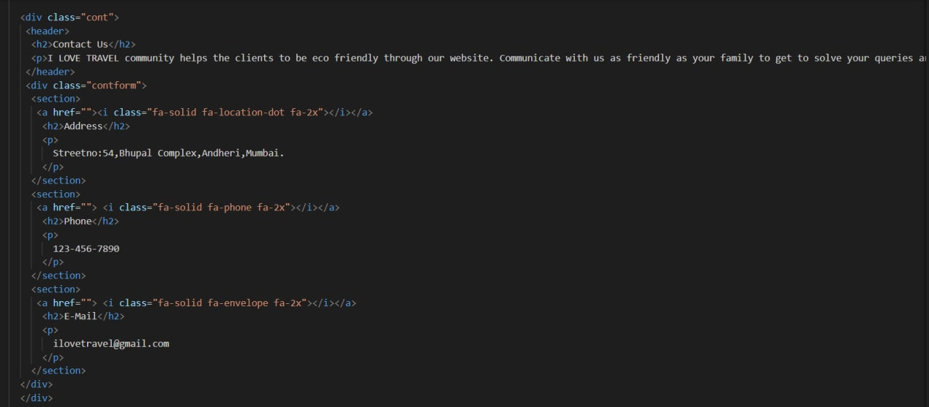

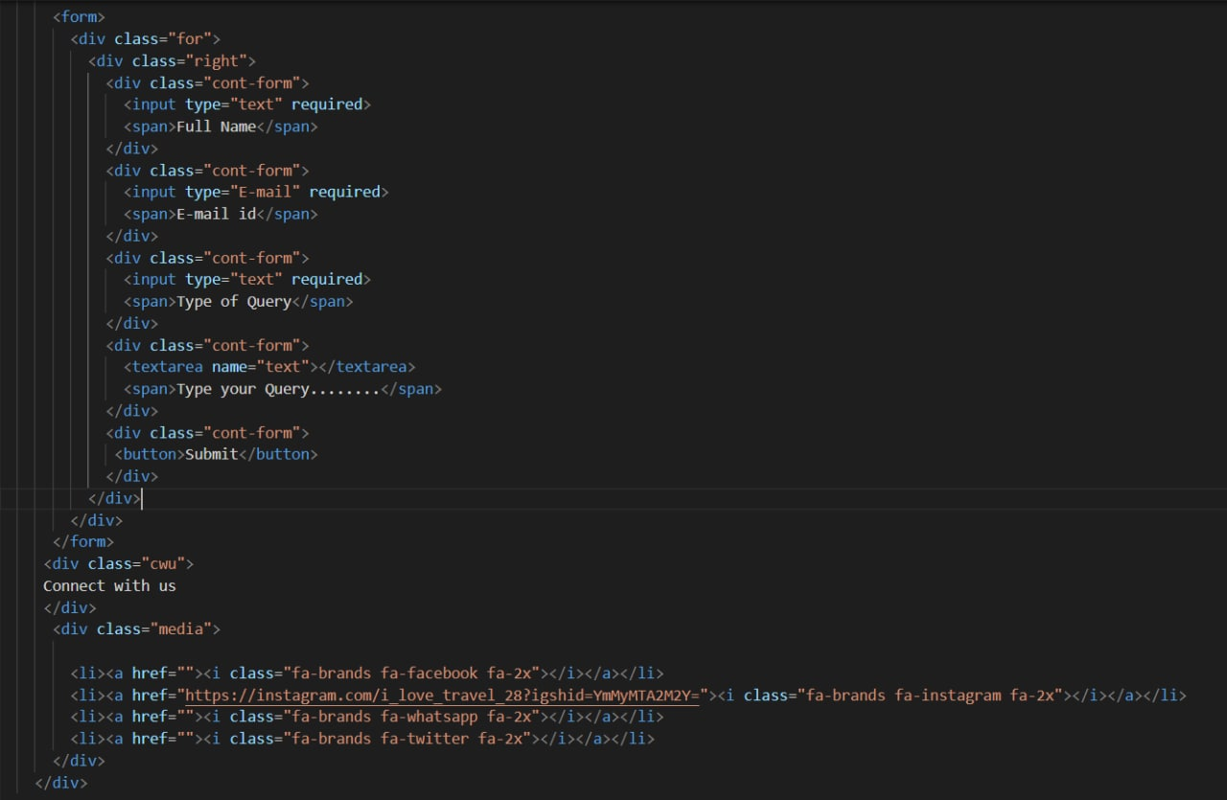

1. 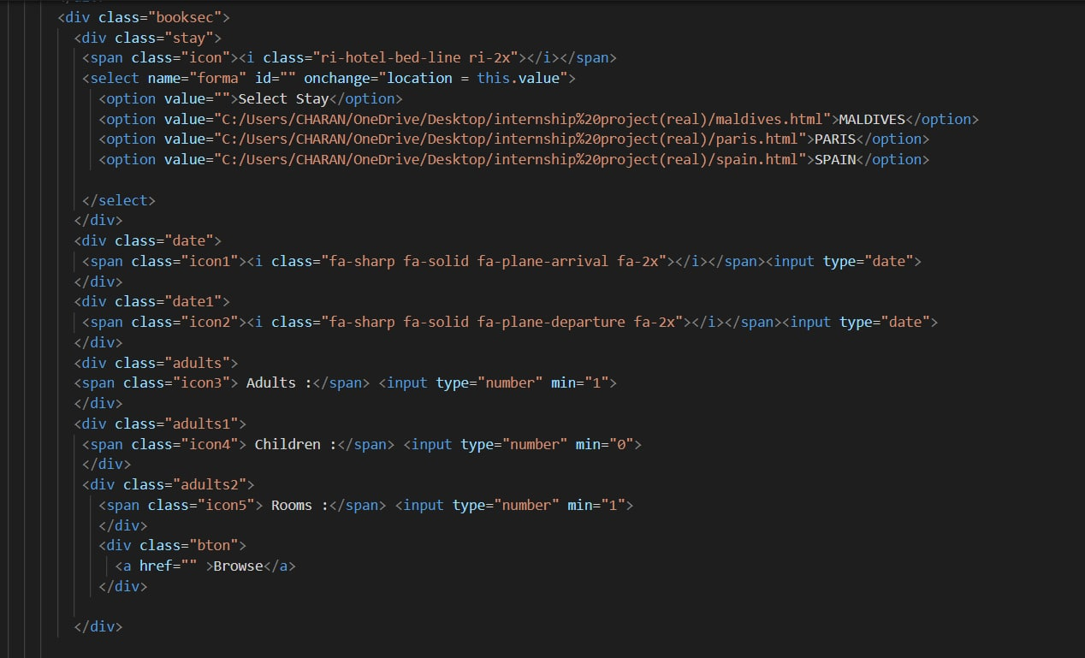**Explore hotels:** Code for the hotels browse section.
2. **Explore hotels:**. Code for hotel brouchers

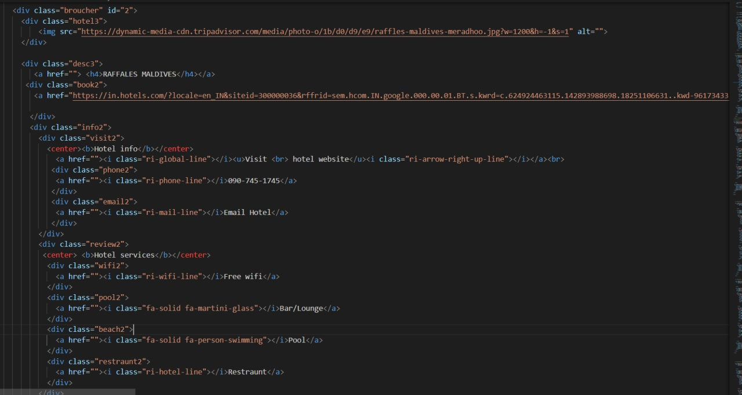

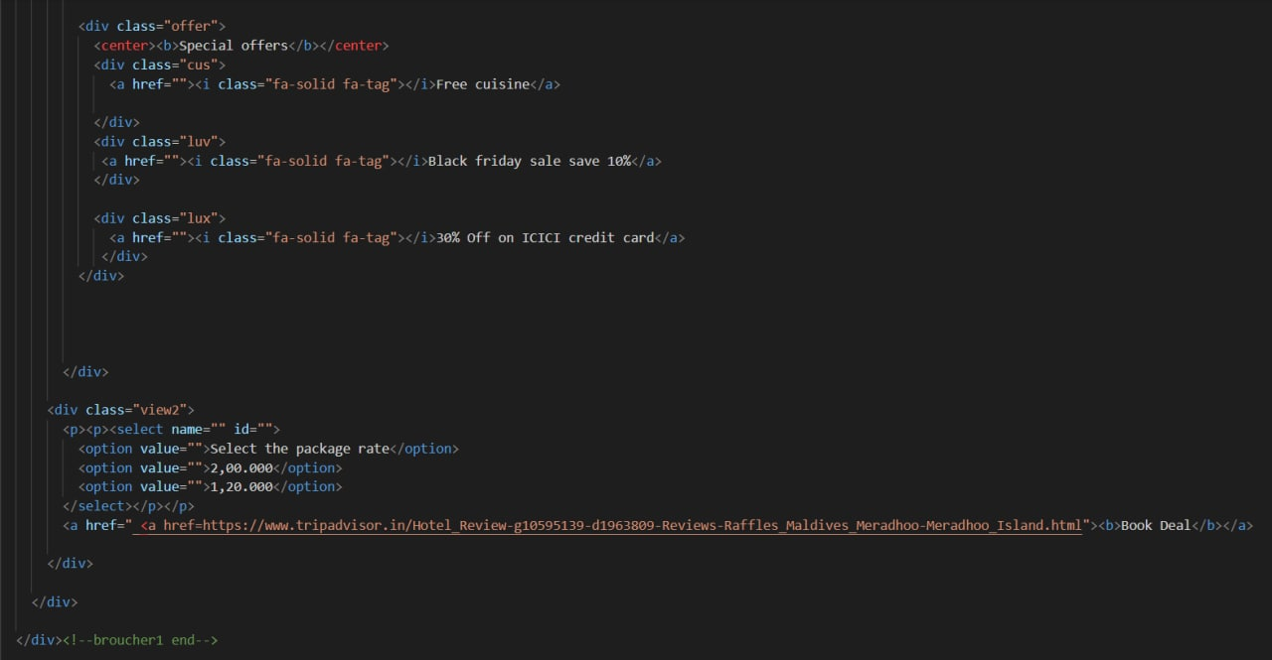

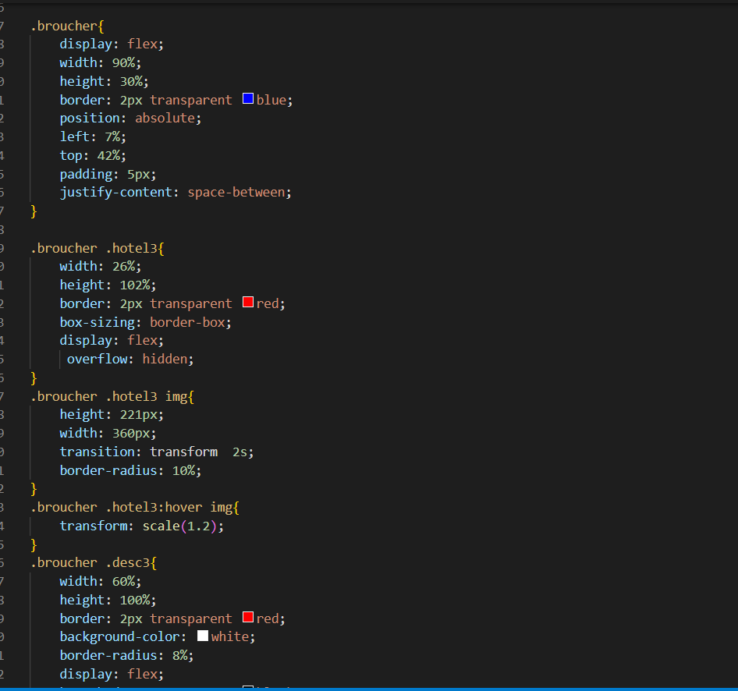

**Website screenshots:**

1. **Cover/Home page** of I LOVE TRAVEL website:

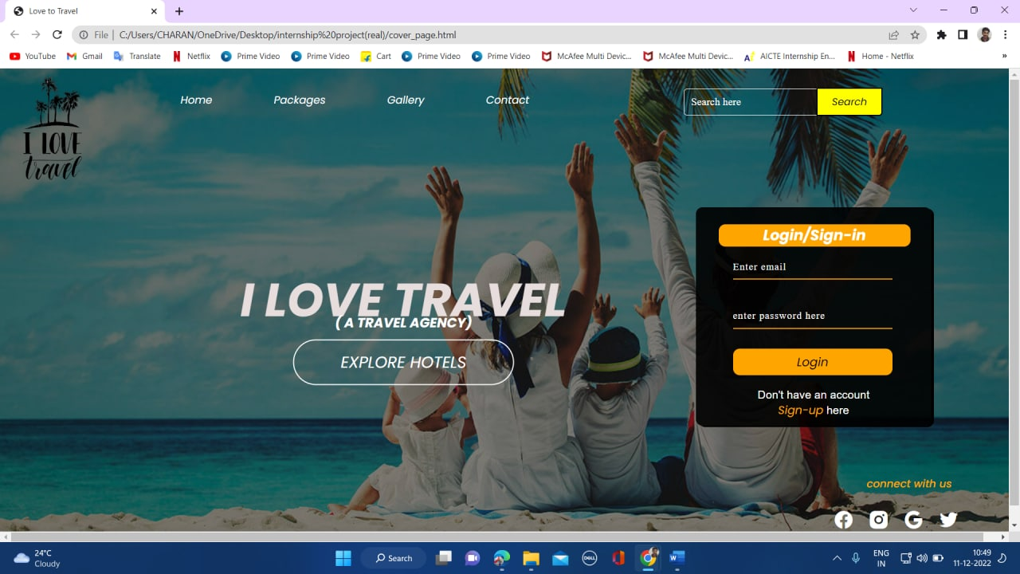

1. **Packages** of I LOVE TRAVEL website:

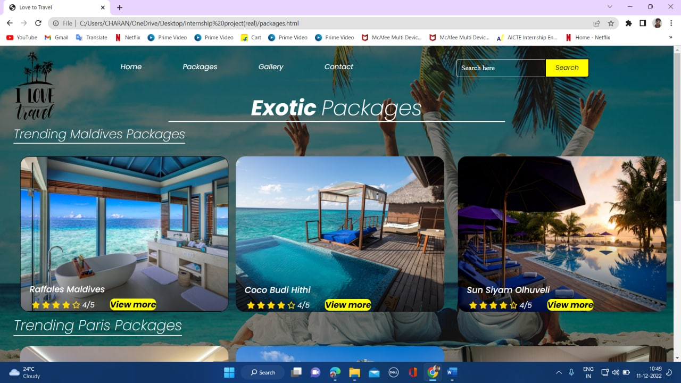

1. **Packages:** Hover effect on packages cards information:

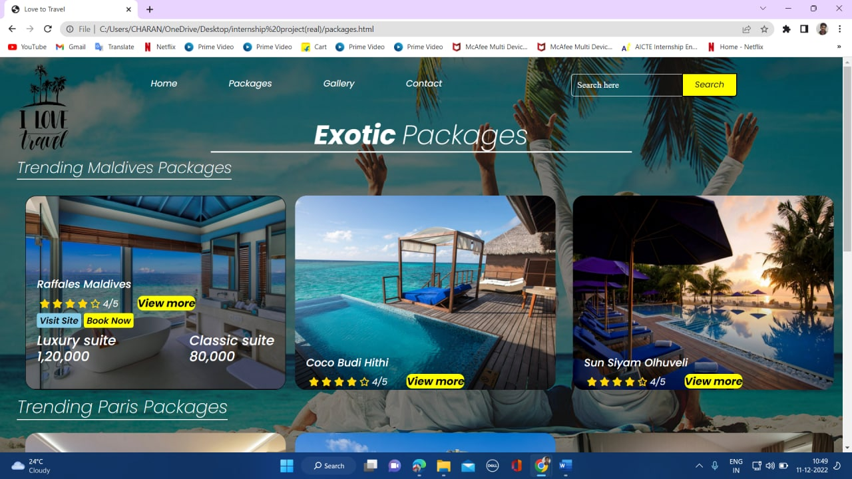

1. **Gallery:** Photo Gallery of Travel destinations.

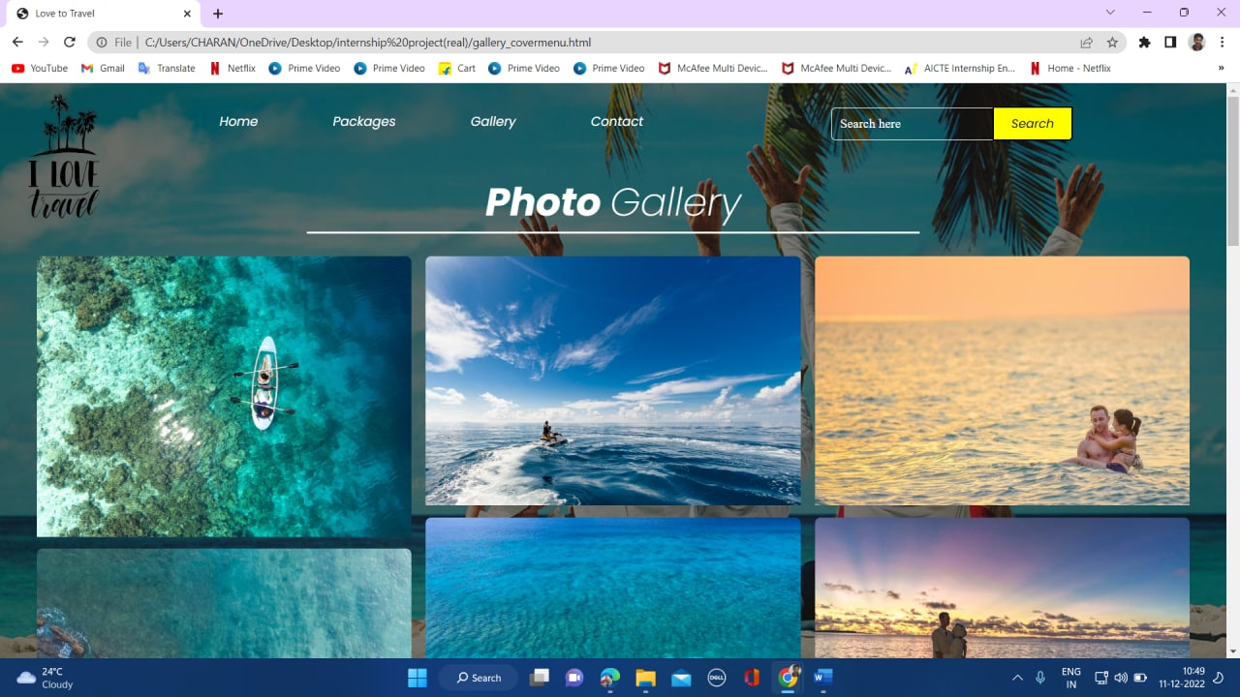

1. **Contact:** This Navigation menu bar helps to contact us.

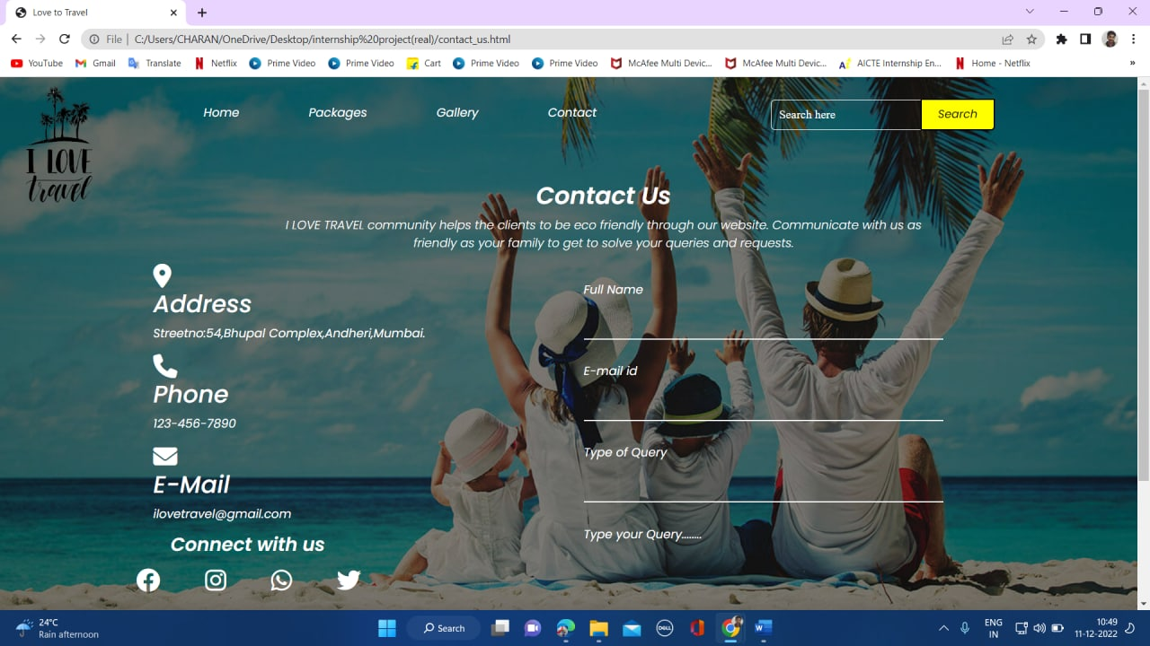

1. 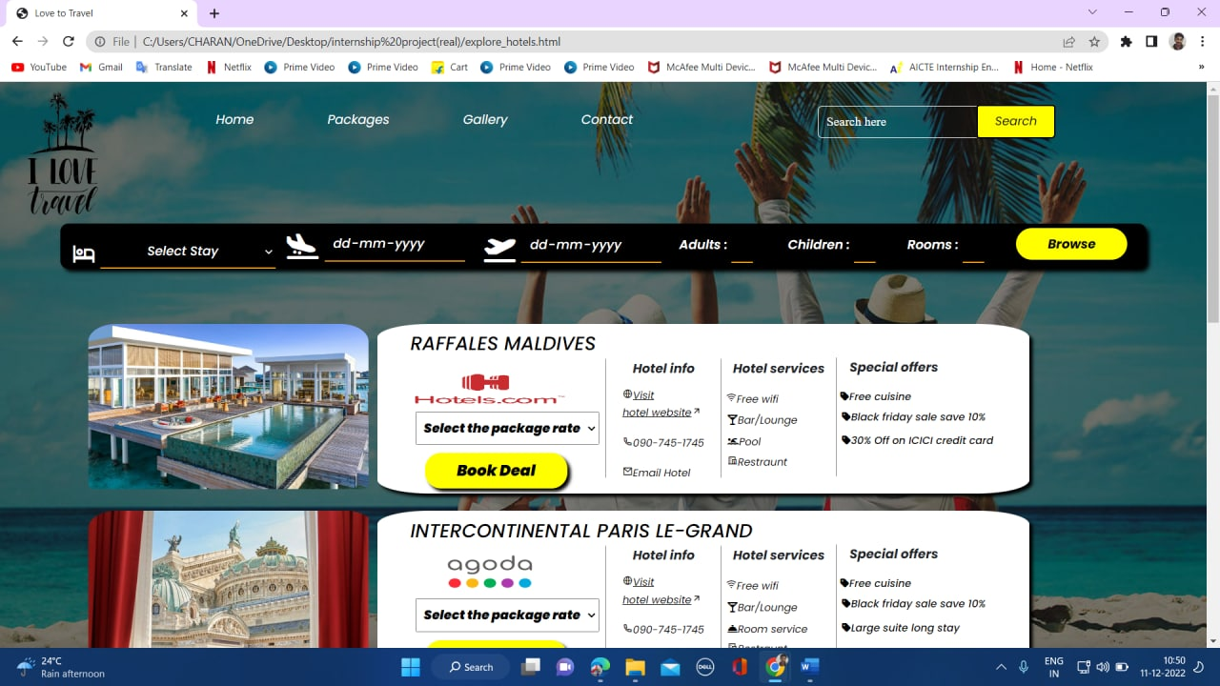**Explore hotels:** A site to visit or explore different travel destinations.
2. **Explore hotels:** Different Resorts/Hotels filtered according to client’s selected stay.

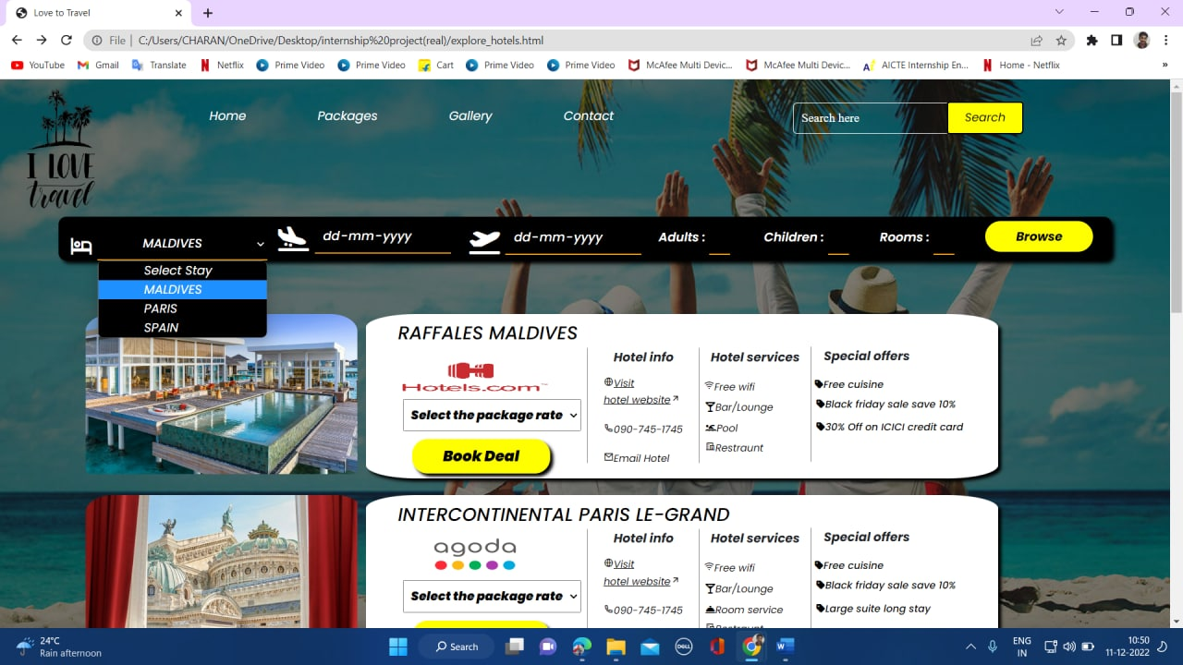

1. **Explore hotels:** Resorts /Hotels are filtered according to selected stay.

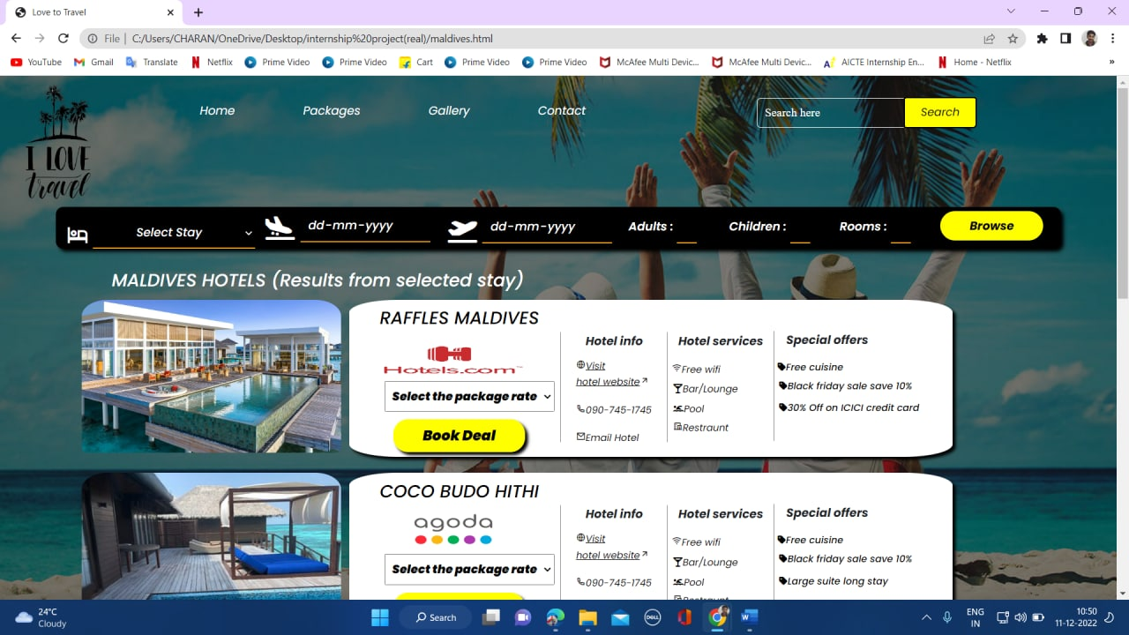

1. **Explore hotels:** Different Resorts/Hotels filtered according to client’s selected stay.

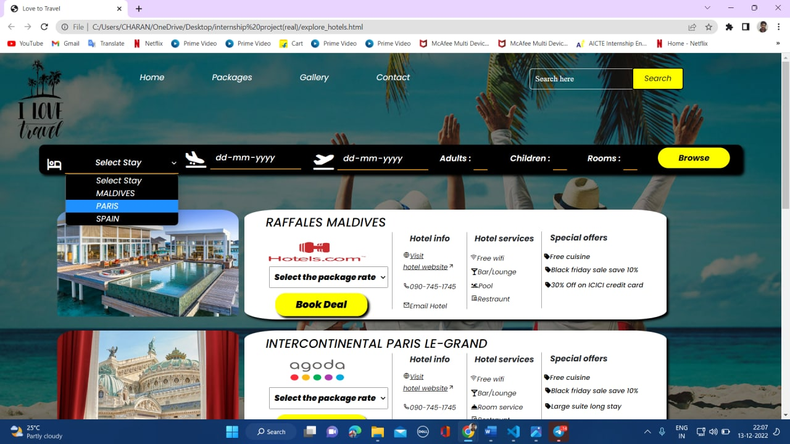

1. **Explore hotels**: Resorts /Hotels are filtered according to selected stay.

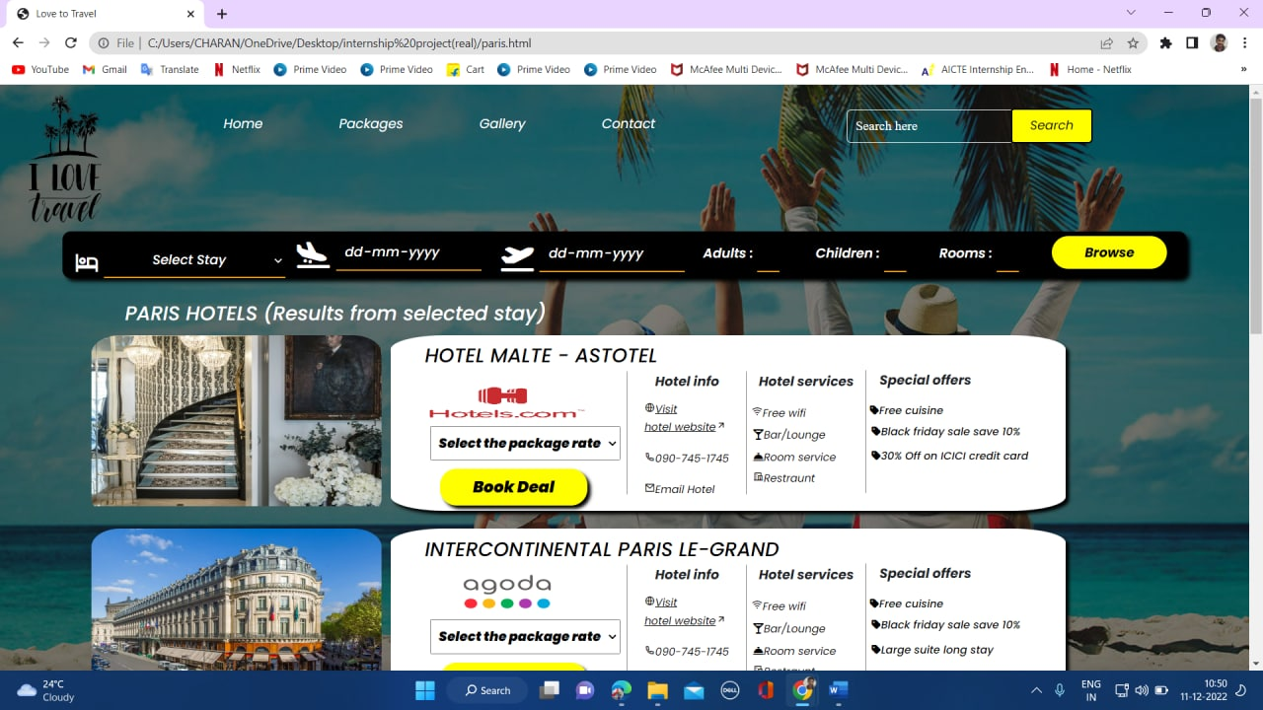

1. **Explore hotels**: Resorts /Hotels are filtered according to selected stay.

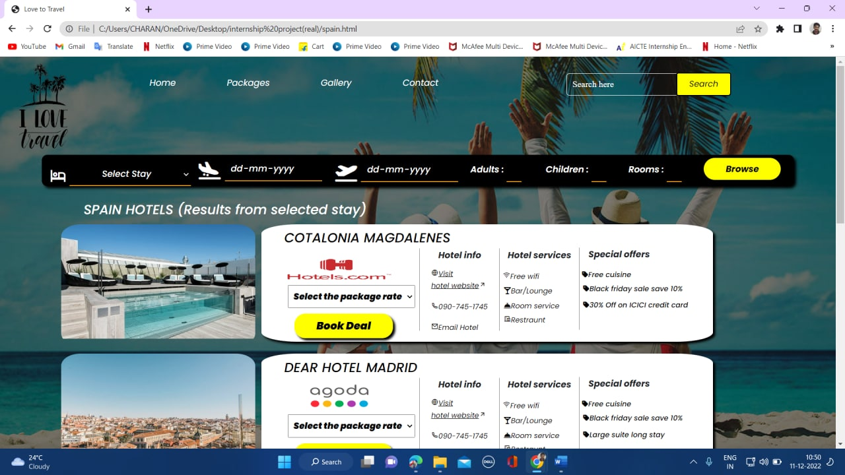

1. **Cover page/Home page search bar:** Search bar

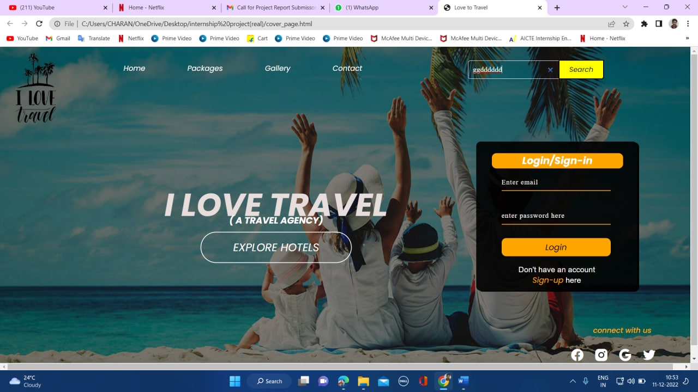

1. 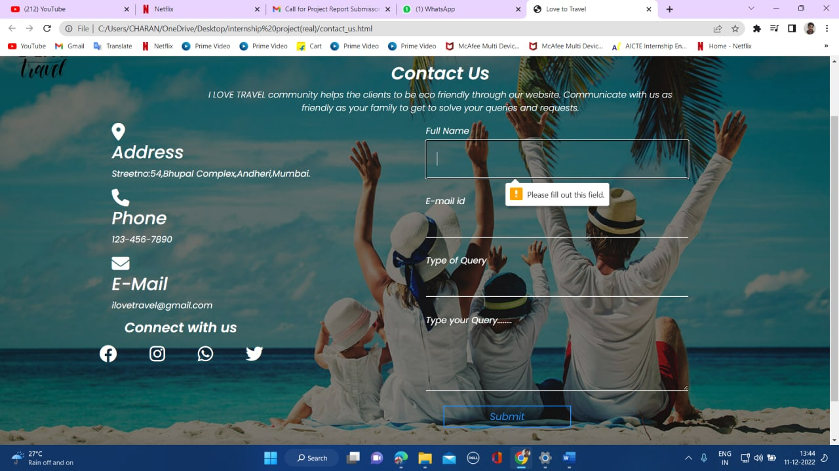
2. **Contact:** Required field set for important information of clients for contacting.
3. **Contact:** Hover Effect on social media accounts of travel agency.

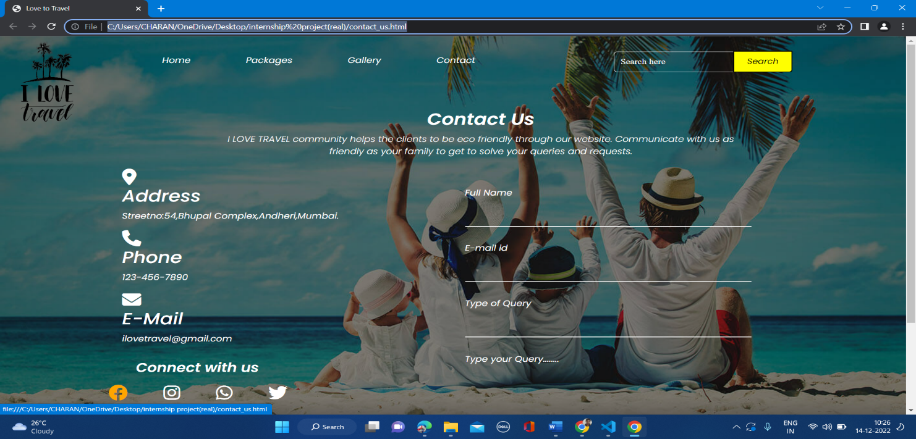

# References:

* <https://www.youtube.com/>
* <https://www.geeksforgeeks.org/web-technology/html-css/>
* <https://www.pexels.com/> (for images)